Step 1: Start Kafka and Zookeeper

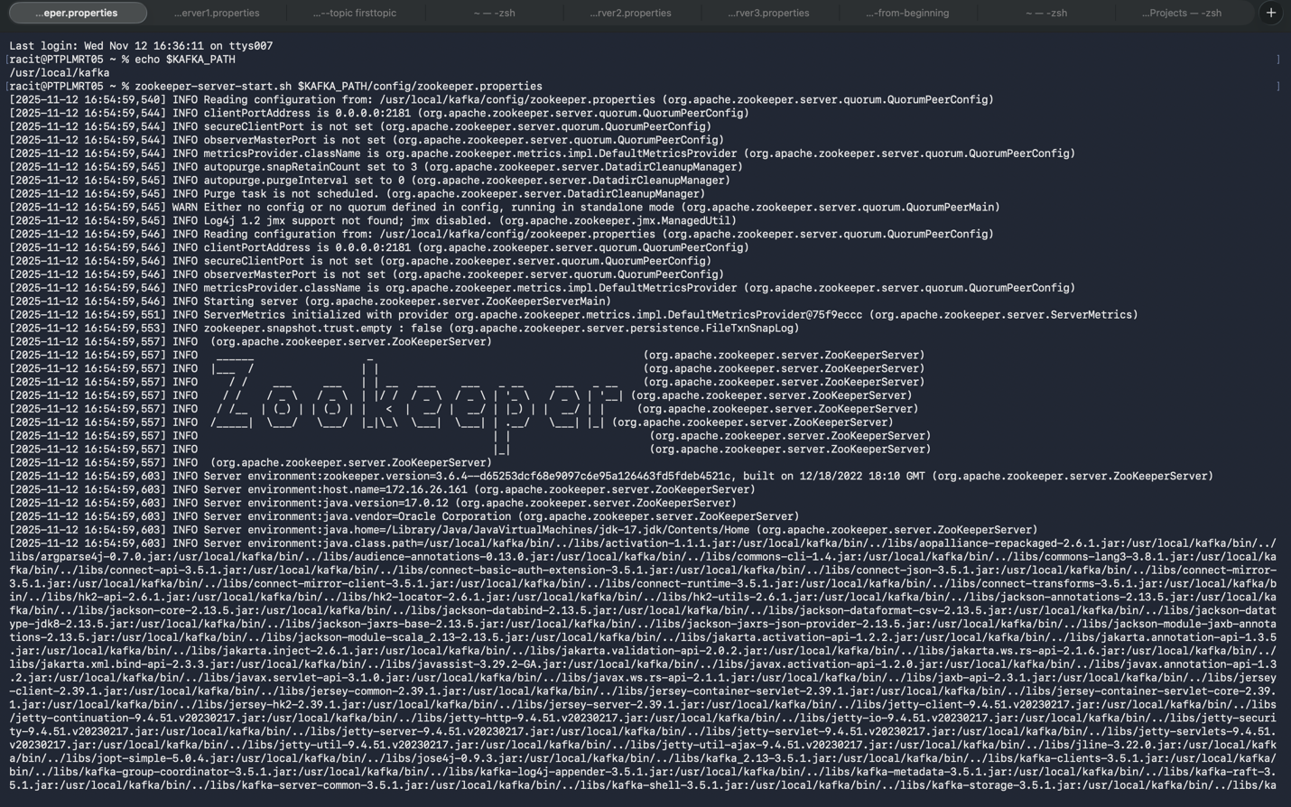

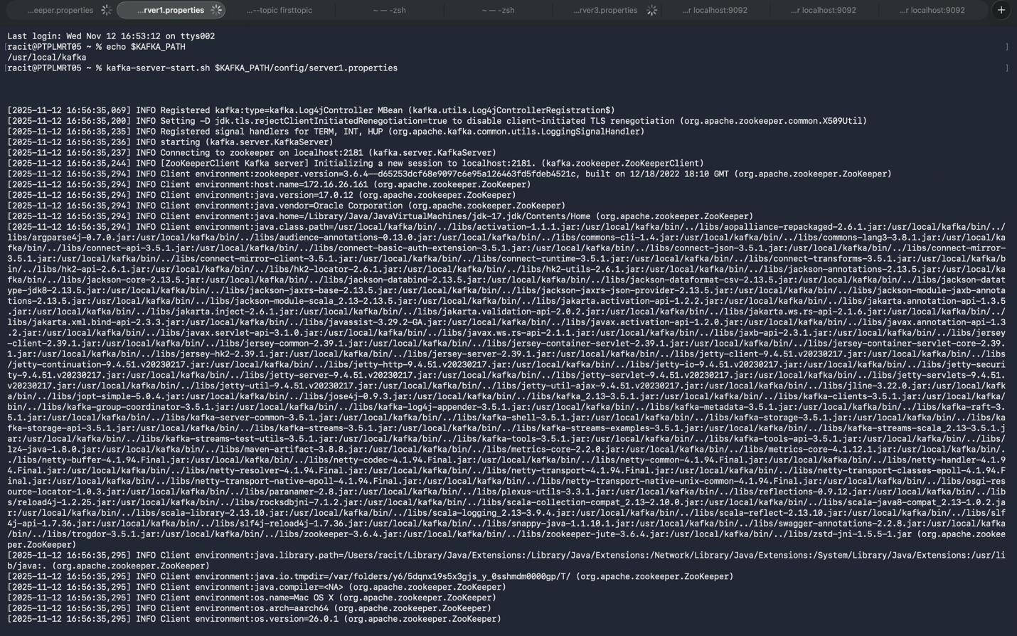

Step 2: Create Kafka Topics

1. Create a topic orders with 3 partitions and replication factor 2:



2. List all topics to verify:  
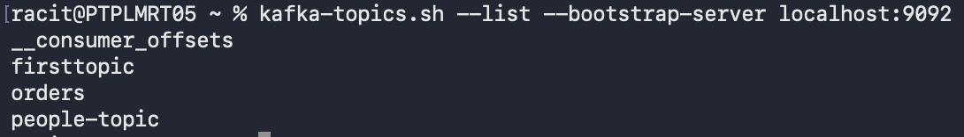

1. Describe the topic to see partitions and leader info:

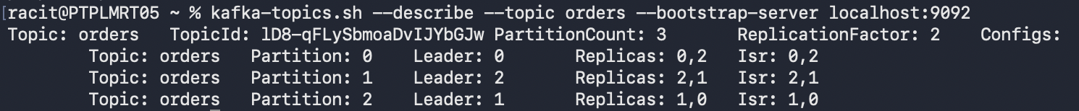

Step 3: Produce Messages

1. Start a Kafka Producer to send order messages:

bin/kafka-console-producer.sh --topic orders --bootstrap-server localhost:9092

2. Send a few sample messages:

OrderID:1001,Item:Laptop,Quantity:2

OrderID:1002,Item:Mobile,Quantity:1

OrderID:1003,Item:Headphones,Quantity:5

Step 4: Consume Messages and Observe Partitions

1. Start a Kafka Consumer with partition and offset info displayed:

bin/kafka-console-consumer.sh --topic orders --from-beginning --bootstrap-server

localhost:9092 --property print.partition=true --property print.offset=true

2. Observe output, e.g.:

0:0:OrderID:1001,Item:Laptop,Quantity:2

1:0:OrderID:1002,Item:Mobile,Quantity:1

2:0:OrderID:1003,Item:Headphones,Quantity:5

a. Format: partition:offset:message  
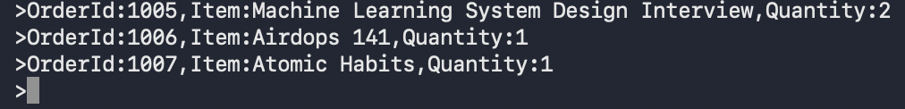  
  
  
  
  
  
  
  
Step 5: Use Consumer Groups

1. Start multiple consumers in the same group to simulate load balancing:

bin/kafka-console-consumer.sh --topic orders --group retailGroup --bootstrap-server

localhost:9092

localhost:9092

bin/kafka-console-consumer.sh --topic orders --group retailGroup --bootstrap-server

2. Produce more messages and observe partition assignment among consumers.

3. List consumer groups:

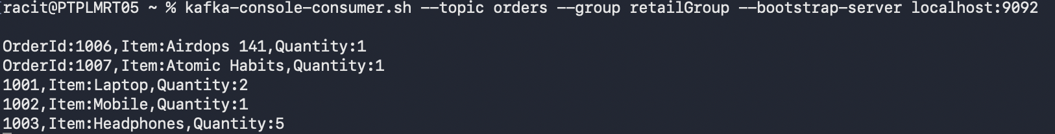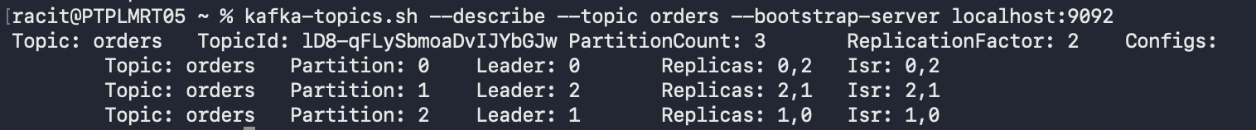  
Step 7: Explore Replication Factor

• Describe topic orders to see leader and replicas:

bin/kafka-topics.sh --describe --topic orders --bootstrap-server localhost:9092

• Stop a broker and observe that messages are still available due to replication.

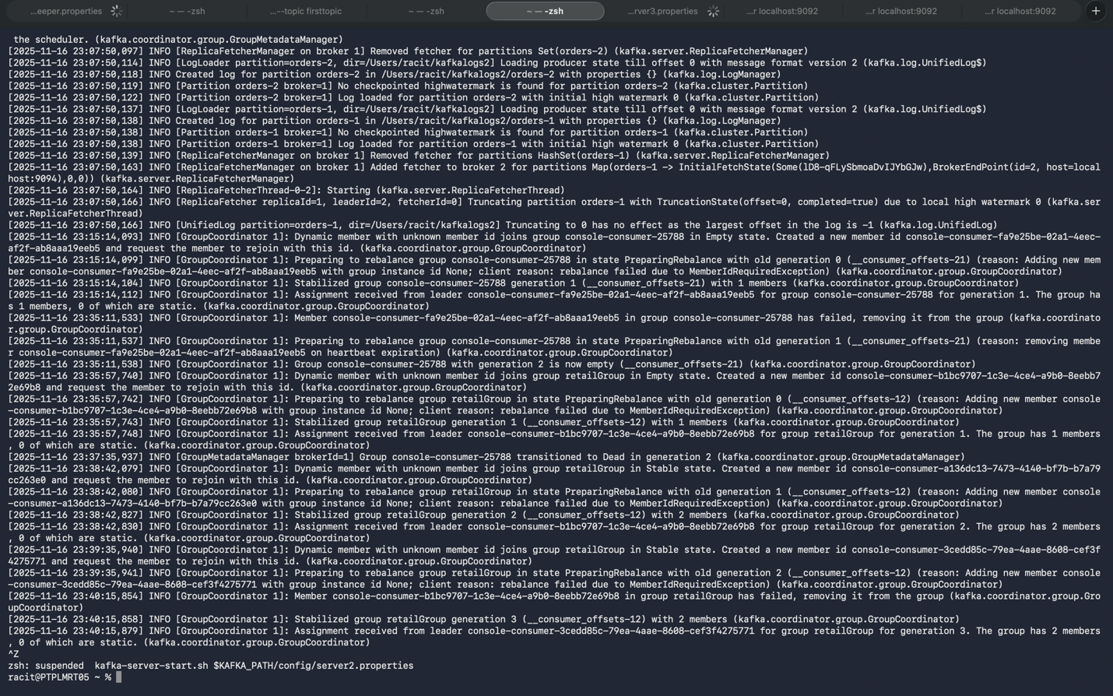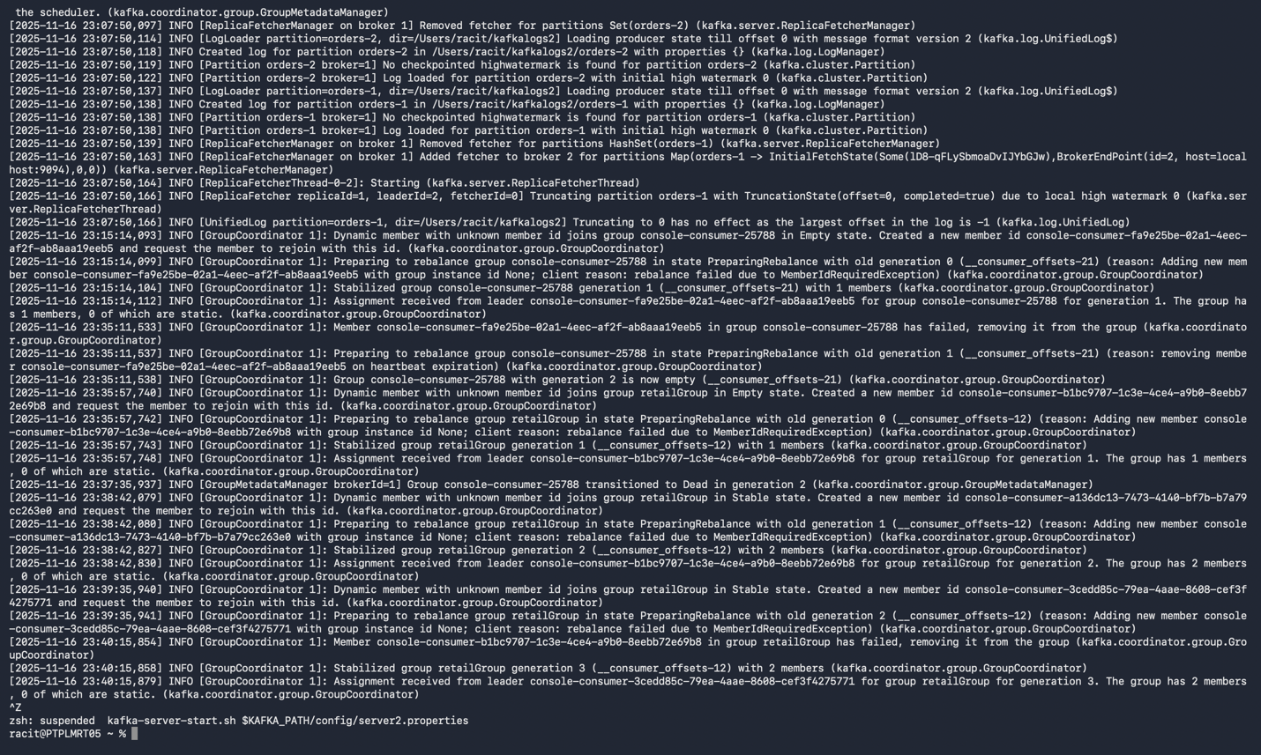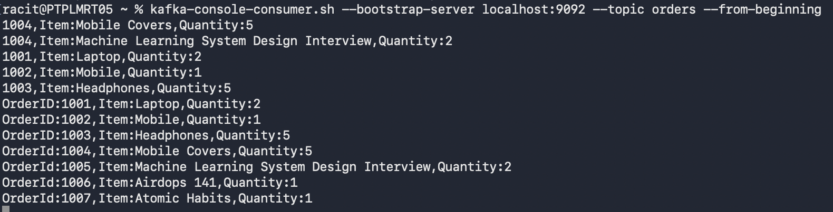  
  
Step 8: Cleanup

• Delete the topic:

bin/kafka-topics.sh --delete --topic orders --bootstrap-server localhost:9092

